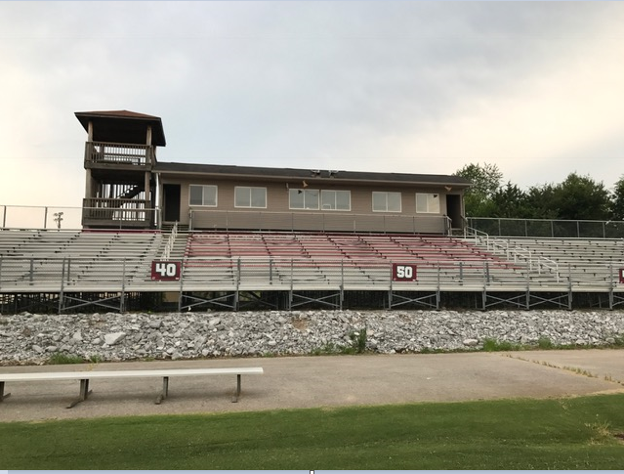
Example:
Section E
Seat 25
40 & 50 Yard Line
Section E - O
Seats 1-25

Between 40 & 50 Yard Line
Section E | 1 | 2 | 3 | 4 | 5 | 6 | 7 | 8 | 9 | 10 | 11 | 12 | 13 | 14 | 15 | 16 | 17 | 18 | 19 | 20 | 21 | 22 | 23 | 24 | 25
Section F | 1 | 2 | 3 | 4 | 5 | 6 | 7 | 8 | 9 | 10 | 11 | 12 | 13 | 14 | 15 | 16 | 17 | 18 | 19 | 20 | 21 | 22 | 23 | 24 | 25
Section G | 1 | 2 | 3 | 4 | 5 | 6 | 7 | 8 | 9 | 10 | 11 | 12 | 13 | 14 | 15 | 16 | 17 | 18 | 19 | 20 | 21 | 22 | 23 | 24 | 25
Section H |  |  | 3 | 4 | 5 | 6 | 7 | 8 | 9 | 10 | 11 | 12 | 13 | 14 | 15 | 16 | 17 | 18 | 19 | 20 | 21 | 22 | 23 | 24 | 25
Section I |  |  | 3 | 4 | 5 | 6 | 7 | 8 | 9 | 10 | 11 | 12 | 13 | 14 | 15 | 16 | 17 | 18 | 19 | 20 | 21 | 22 | 23 | 24 | 25
Section J |  |  | 3 | 4 | 5 | 6 | 7 | 8 | 9 | 10 | 11 | 12 | 13 | 14 | 15 | 16 | 17 | 18 | 19 | 20 | 21 | 22 | 23 | 24 | 25
Section K | 1 | 2 | 3 | 4 | 5 | 6 | 7 | 8 | 9 | 10 |  |  | 13 | 14 | 15 | 16 | 17 | 18 | 19 | 20 | 21 | 22 | 23 | 24 | 25
Section L | 1 | 2 | 3 | 4 | 5 | 6 | 7 | 8 | 9 | 10 | 11 | 12 | 13 | 14 | 15 | 16 | 17 | 18 | 19 | 20 | 21 | 22 | 23 | 24 | 25
Section M | 1 | 2 | 3 | 4 | 5 | 6 | 7 | 8 | 9 | 10 | 11 | 12 | 13 | 14 | 15 | 16 | 17 | 18 | 19 | 20 | 21 | 22 | 23 | 24 | 25
Section N | 1 | 2 | 3 | 4 | 5 | 6 | 7 | 8 | 9 | 10 | 11 | 12 | 13 | 14 | 15 | 16 | 17 | 18 | 19 | 20 | 21 | 22 | 23 | 24 | 25
Section O | 1 | 2 | 3 | 4 | 5 | 6 | 7 | 8 | 9 | 10 | 11 | 12 | 13 | 14 | 15 | 16 | 17 | 18 | 19 | 20 | 21 | 22 | 23 | 24 | 25

*Reserved

